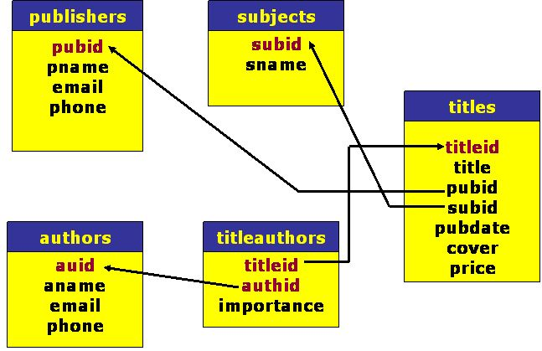

**Sign in to oracle using command prompt and run following queries.**

CREATE TABLE PUBLISHERS

(

PUBID NUMBER(3) PRIMARY KEY,

PNAME VARCHAR2(30),

EMAIL VARCHAR2(50) UNIQUE,

PHONE VARCHAR2(30)

);

CREATE TABLE SUBJECTS

(

SUBID VARCHAR2(5) PRIMARY KEY,

SNAME VARCHAR2(30)

);

CREATE TABLE AUTHORS

(

AUID NUMBER(5) PRIMARY KEY,

ANAME VARCHAR2(30),

EMAIL VARCHAR2(50) UNIQUE,

PHONE VARCHAR2(30)

);

CREATE TABLE TITLES

(

TITLEID NUMBER(5) PRIMARY KEY,

TITLE VARCHAR2(30),

PUBID NUMBER(3),

CONSTRAINT TITLES_PUBID_FK foreign key (pubid) REFERENCES PUBLISHERS(PUBID),

SUBID VARCHAR2(5),

CONSTRAINT TITLES_SUBID_FK foreign key(subid) REFERENCES SUBJECTS(SUBID),

PUBDATE DATE,

COVER CHAR(1),

CONSTRAINT TITLES_COVER_CHK CHECK ( COVER IN ('P','H','p','h')),

PRICE NUMBER(4)

);

CREATE TABLE TITLEAUTHORS

(

TITLEID NUMBER(5),

CONSTRAINT TITLESAUTHORS_TITLEID_FK foreign key (titleid) REFERENCES TITLES(TITLEID),

AUID NUMBER(5),

CONSTRAINT TITLESAUTHORS_AUTHID_FK foreign key (auid) REFERENCES AUTHORS(AUID),

IMPORTANCE NUMBER(2),

CONSTRAINT TITLESAUTHORS_PK PRIMARY KEY(TITLEID,AUID)

);

INSERT INTO SUBJECTS VALUES ('ORA','ORACLE DATABASE 10g');

INSERT INTO SUBJECTS VALUES ('JAVA','JAVA LANGUAGE');

INSERT INTO SUBJECTS VALUES ('JEE','JAVA ENTEPRISE EDITION');

INSERT INTO SUBJECTS VALUES ('VB','VISUAL BASIC.NET');

INSERT INTO SUBJECTS VALUES ('ASP','ASP.NET');

INSERT INTO PUBLISHERS VALUES (1,'WILLEY','WDT@VSNL.NET','91-11-23260877');

INSERT INTO PUBLISHERS VALUES (2,'WROX','INFO@WROX.COM',NULL);

INSERT INTO PUBLISHERS VALUES (3,'TATA MCGRAW-HILL','FEEDBACK@TATAMCGRAWHILL.COM','91-11-33333322');

INSERT INTO PUBLISHERS VALUES (4,'TECHMEDIA','BOOKS@TECHMEDIA.COM','91-11-33257660');

INSERT INTO AUTHORS VALUES (101, 'HERBERT SCHILD','HERBERT@YAHOO.COM',NULL);

INSERT INTO AUTHORS VALUES (102, 'JAMES GOODWILL','GOODWILL@HOTMAIL.COM',NULL);

INSERT INTO AUTHORS VALUES (103, 'DAVAID HUNTER','HUNTER@HOTMAIL.COM',NULL);

INSERT INTO AUTHORS VALUES (104, 'STEPHEN WALTHER','WALTHER@GMAIL.COM',NULL);

INSERT INTO AUTHORS VALUES (105, 'KEVIN LONEY','LONEY@ORACLE.COM',NULL);

INSERT INTO AUTHORS VALUES (106, 'ED. ROMANS','ROMANS@THESERVERSIDE.COM',NULL);

INSERT INTO TITLES VALUES (1001,'ASP.NET UNLEASHED',4,'ASP','12-APR-02','P',540);

INSERT INTO TITLES VALUES (1002,'ORACLE10G COMP. REF.',3,'ORA','1-MAY-05','P',575);

INSERT INTO TITLES VALUES (1003,'MASTERING EJB',1,'JEE','3-FEB-05','P',475);

INSERT INTO TITLES VALUES (1004,'JAVA COMP. REF',3,'JAVA','3-APR-05','P',499);

INSERT INTO TITLES VALUES (1005,'PRO. VB.NET',2,'VB','15-JUN-05','P',450);

INSERT INTO TITLEAUTHORS VALUES (1001,104,1);

INSERT INTO TITLEAUTHORS VALUES (1002,105,1);

INSERT INTO TITLEAUTHORS VALUES (1003,106,1);

INSERT INTO TITLEAUTHORS VALUES (1004,101,1);

INSERT INTO TITLEAUTHORS VALUES (1005,103,1);

INSERT INTO TITLEAUTHORS VALUES (1005,102,2);